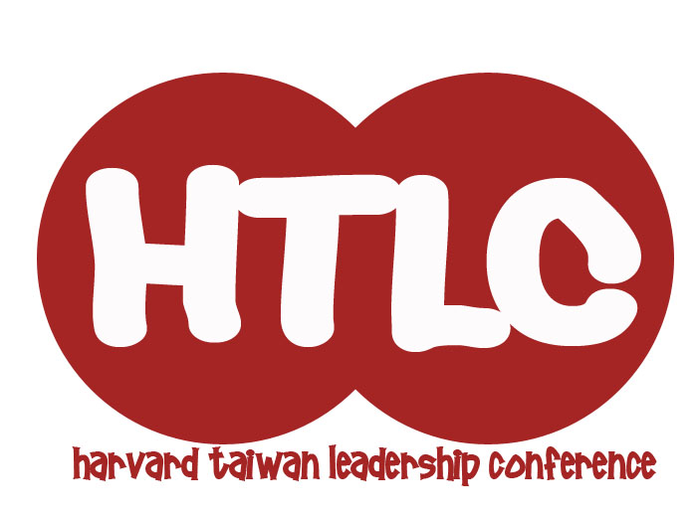
Harvard Taiwan Leadership Conference 2010
Student Application
Thank you for your interest in the Harvard Taiwan Leadership Conference (HTLC)! The Harvard Taiwan Leadership Conference empowers individuals to transform their communities creatively, critically and collaboratively. As a joint effort by the Harvard-Radcliffe Taiwanese Cultural Society and National Taipei University, HTLC strives to motivate participants to cultivate strong independent leadership skills, work effectively as a team, and recognize the importance of social change. At our conference, we seek to foster an environment that can develop strong leaders who will ultimately impact the world around them.
The 2010 Conference will run from August 20-26, 2010 at the National Taipei University Campus in Sansia. Below you will find the application for 2010 Students. Students will attend the conference free of charge and will be provided housing, meals and other amenities.
We are looking for motivated and passionate individuals who care a lot about their communities, and we recognize the importance of cultivating diversity and an atmosphere of respect and peer learning. No matter where you are from or what school you go to, we highly encourage you to apply. Please complete the following questions and email your completed applications to HTLCexec@gmail.com by April 9, 2010, 11:59pm (Taiwan time).
*IMPORTANT: you must save your document as “Student_Last name_First name.doc” For example, Joe Wang would save his document as “Student_Wang_Joe.doc”
Please let us know if you have any questions by contacting us at HTLCexec@gmail.com! We look forward to reading your application, and will announce our decisions by April 26, 2010.

Harvard Taiwan Leadership Conference 2010
Student Application
Part I: Basic Information
Name (Chinese): ___________________________
Last Name (English): _______________________ First name: ___________________________
Date of Birth (year/month/day): _________________________ Sex (male/female): __________
Home Address: _________________________________________________________________
Telephone number (Home): ______________________ Mobile: _________________________
E-mail Address: ____________________________

School Information:
High School (English): ___________________________ Chinese: _______________________
School Address: ________________________________________________________________
City: ___________________________ Country: _____________________
Evaluate Your English Abilities (On a scale of 1-10, 1: basic, 10: fluent): _______

Part II: Essay
Please take some time to answer the following short essay questions in English. We will be reading these essays very carefully and will be basing our admissions decisions on the quality, originality, and creativity of your answers. Good luck!
Note: Please try to limit your answers to 300 words per question. Thank you!
1. Why do you want to participate in the Harvard Taiwan Leadership Conference? What do you hope to gain from this conference?

2. Consider an issue that affects your community. How would you approach this problem? What steps would you take to resolve it?

3. Please list some of your extracurricular activities and interests (in order of importance), and briefly describe your involvement in each one. Afterwards, please select one and explain why it is important to you.
 | Extracurricular | Description
1.
2.
3.
4.
5.

Extracurricular:

*Thank you for completing the HTLC 2010 Student Application. Again, please title this document “Student_Last name_First name.doc” and email it to HTLCexec@gmail.com. We look forward to reading your application!

