2011哈佛臺灣英文領導營
Harvard Taiwan Leadership Conference 2011

活動計畫書

計畫執行期間：2011年2月1日 至 9 月1日
活動日期：2011年8月19日 至 25日
活動地點：國立臺北大學三峽校區

贊助單位：昇恒昌基金會
主辦單位：哈佛臺灣文化學會 http://www.hcs.harvard.edu/taiwan
國立臺北大學 http://www.ntpu.edu.tw

計畫代表人：國立臺北大學校長 侯崇文
計畫主持人：會計學系教授兼副校長 王怡心
法律學系教授兼學務長 吳嘉生
計畫共同主持人：
應用外語學系副教授兼系主任 左偉芳
休閒運動與管理學系助理教授 謝立文
計畫聯絡人：休閒運動與管理學系助理教授 謝立文

執行單位：
國立臺北大學學生事務處課指組：
張耀鴻組長 (02)26748189-66216，范瑞昭小姐 (02)26748189-66215
地址：237新北市三峽區大學路151號

目 錄
page
計畫簡介 …………………………………………………………… 2
工作計畫(日期、團隊、預算) …………………………………….. 3
英文宣傳資料 ……………………………………………………….. 4
課程規劃 …………………………………………………………… 5
招生說明 ……………………………………………………………… 6
報名表 ………………………………………………………………… 7
HTLC2010照片 ………………………………………………………. 9
計畫簡介

哈佛臺灣英文領導營目的在灌輸領導觀念與激發臺灣青年的進取心。營隊以同儕教導的方式進行，所有的營隊講師皆為目前就讀於美國哈佛大學的學生。希望藉由辯論與溝通技巧的學習，發展青年學生自尊與自信。學員習得之技能，不僅可運用在課堂討論學習中，亦可應用在未來職場或其他日常活動。哈佛臺灣英文領導營由本校當時之蔡學務長於2008年開辦，招收全國50名優秀高中生，為期五天活動深受好評，2009年因新流感而停辦，2010年活動除了增加為七天外，更增收學員至100名，2011年則延續去年七天的活動時間並將學員人數再次調整。冀望在17名哈佛大學生的指導下，強化臺灣未來主人翁之領導力。

營隊特色：
美國哈佛大學學生全程英文授課

招生對象：
本計劃擬邀請70名英文優良且具備領導才能潛力之高中生參加。

收收方式：
於2月底廣發報名資訊於全國各高中，4月底報名截止，依往例將有300-400名學生報名，哈佛講師將針對學生自傳與看法於5月底篩選出最具潛力之70名學員。

主辦單位簡介：
哈佛臺灣文化學會，一個以哈佛大學學生為主的組織，超過80名的成員都致力於宣揚臺灣文化於美國哈佛校園及地方社區，如今更計劃將自身所學帶回臺灣，希望貢獻一己之力提升臺灣未來競爭力。
國立臺北大學，2000年改制為台北大學後，座落於環境優美的三峽新校區，承襲過去深厚的行政專校與中興法商基礎，致力開展校務新貌，朝向法律、經濟、商管、資訊、科技等五大路線並進。以「追求真理、服務人群」為治學願景，沿襲建校以來之優秀傳統，致力於培養社會與企業所需之人才。

工作計畫

一、計畫時程表：
日期 | 工作內容
2月底 | 寄發公文至全國高中，宣傳
3月 | 徵招臺北大學學生志工
4月 | 申請截止日期
5月1日 | 確認哈佛大學學生名單
5月31日 | 公佈錄取名單，寄發通知書
6月1日 | 行文拜會總統府相關事宜
6月15日 | 行文有關單位住宿、活動、課程相關場地設施配套事宜
6月30日 | 志工培訓
8月15日 | 相見歡
8月16-18日 | 會前會議及前置作業
8月19-25日 | 正式活動及參訪
8月26-30日 | 會後檢討

二、工作團隊：
國立臺北大學
侯崇文(校長)、王怡心(副校長)、吳嘉生(學務長)、詹景裕(校友中心主任)、左偉芳（應外系主任）、謝立文（運管系助理教授）、張耀鴻(課指組組長) 、范瑞昭(課指組組員)、石展丞(學生召集人)
哈佛大學
Jenny Chen (HTLC2011召集人),Tzu-Ying Chuang (HTLC2010召集人), Jackie Hsieh (HTLC2009召集人), Eric Lu (HTLC2008召集人)

三、活動預算（詳附錄）

膳食費 | ﹩231,500
交通費 | ﹩26,000
雜項費用 | ﹩172,500
補助哈佛同學機票費 | ﹩170,000
合計 | ﹩600,000

哈佛臺灣英文領導營宣傳資料

Harvard Taiwan Leadership Conference 2011

Hosted by the Harvard Taiwanese Cultural Society and
National Taipei University

Apply to the Harvard Taiwan Leadership Conference 2011!

Applications are due April 18, 2011. Successful applicants will be notified of their status middle of May.

The Harvard Taiwan Leadership Conference aims to instill a sense of leadership and initiative in the minds of the youth of Taiwan. HTLC is based on the vision of peers teaching each other as all of our teachers are current Harvard University students. By learning different skill sets involved with leadership including debate and communication, young students will naturally develop a greater self-esteem and confidence. Furthermore, students will realize to not only apply these skills in the classroom, but also during their daily activities such as on the sports field. These characteristics are absolutely crucial in teaching the future leaders of tomorrow!

The conference will be held starting on August 19, 2011 and ending on August 25, 2011. Students and teachers will stay on National Taipei University’s Sansia campus. Students will attend the conference free of charge, but they are expected to pay a deposit at the beginning. Students are expected to stay the entire duration of the conference, and at the end of the conference they will receive their deposits back.

哈佛臺灣英文領導營課程規劃
Time | 8/19 | 8/20 | 8/21 | 8/22 | 8/23 | 8/24 | 8/25
8am |  | -----------------Breakfast-------------- |  |  |  |  | Breakfast
8am |  |  |  |  |  |  | Teacher Speeches, Certificates  (9:30am – 12:000am)
9am | Student Registration | =========Individual Classes======== |  |  |  |  | Teacher Speeches, Certificates  (9:30am – 12:000am)
10am | Opening Speeches |  |  |  |  |  | Teacher Speeches, Certificates  (9:30am – 12:000am)
11am | Opening Speeches |  |  |  |  |  | Teacher Speeches, Certificates  (9:30am – 12:000am)
12pm | -----------------------Lunch--------------------- |  |  |  |  |  | Banquet Lunch
1pm |  | Lecture 1: Pluralim | Lecture 1: What is Debate? | Lecture 1: Mock Interview + Etiquette | Lecture 1: Design Thinking | Lecture 1: Sustainability/ Environmental Issues or Global Health | Banquet Lunch
2pm | Move-In | Break | Break | Lecture 1: Mock Interview + Etiquette | Break |  | Goodbyes and Move-out
2pm | Move-In | Lecture 2: Marketing Activity: Eggdrop | Lecture 2: Creative Writing | Lecture 1: Mock Interview + Etiquette |  |  | Goodbyes and Move-out
3pm | HTLC Olympics | Lecture 2: Marketing Activity: Eggdrop | Lecture 2: Creative Writing | Lecture 1: Mock Interview + Etiquette | Debates (in classrooms) | Break | Goodbyes and Move-out
 |  |  |  | Break | Debates (in classrooms) |  | Goodbyes and Move-out
 |  |  |  | Break Out Sessions | Debates (in classrooms) |  | Goodbyes and Move-out
4pm |  |  |  |  | Winners Debate Demonstration (in auditorium) | HTLC thinks big
5pm | HTLC Olympics | Sports/Chill
6pm | ------------------------Dinner-----------------------
7pm | Class Introductions (individual classrooms) | ==========Extracurricular========== |  |  |  | Final Show
8pm | Extracurricular Introductions (auditorium) |  |  |  |  | Final Show
9pm | Movie | Journals/Reflections |  |  |  | Final Show
10pm | Movie | Free Time |  |  |  | Final Show
11pm | Lights Out/Teachers Meeting | Lights Out/Teachers Meeting

哈佛臺灣英文領導營招生說明
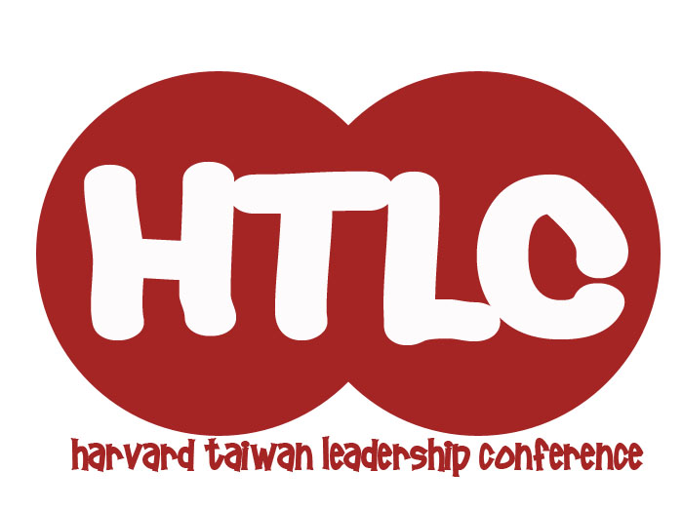
Harvard Taiwan Leadership Conference 2011
Student Application
Thank you for your interest in the Harvard Taiwan Leadership Conference (HTLC)! The Harvard Taiwan Leadership Conference empowers individuals to transform their communities creatively, critically and collaboratively. As a joint effort by the Harvard-Radcliffe Taiwanese Cultural Society and National Taipei University, HTLC strives to motivate participants to cultivate strong independent leadership skills, work effectively as a team, and recognize the importance of social change. At our conference, we seek to foster an environment that can develop strong leaders who will ultimately impact the world around them.
The 2011 Conference will run from August 19-25, 2011 at the National Taipei University Campus in Sansia. Below you will find the application for 2011 Students. Students will attend the conference free of charge and will be provided housing, meals and other amenities.
We are looking for motivated and passionate individuals who care a lot about their communities, and we recognize the importance of cultivating diversity and an atmosphere of respect and peer learning. No matter where you are from or what school you go to, we highly encourage you to apply. Please complete the following questions and email your completed applications to HTLCexec@gmail.com and extra@mail.ntpu.edu.tw by April 18, 2011, 11:59pm (Taiwan time).
*IMPORTANT: you must save your document as “Student_Last name_First name.doc” For example, Joe Wang would save his document as “Student_Wang_Joe.doc”
Please let us know if you have any questions by contacting us at HTLCexec@gmail.com! We look forward to reading your application, and will announce our decisions before the end of May, 2011.
.

哈佛臺灣英文領導營招生報名表
Harvard Taiwan Leadership Conference 2011
Student Application
Part I: Basic Information
Name (Chinese): ___________________________
Last Name (English): _______________________ First name: _________________________
Date of Birth (year/month/day): _________________________ Sex (male/female): ________
Home Address: _________________________________________________________________
Telephone number (Home): ______________________ Mobile: ________________________
E-mail Address: ____________________________

School Information:
High School (English): ___________________________ Chinese: ______________________
School Address: ________________________________________________________________
City: ___________________________ Country: _____________________
Evaluate Your English Abilities (On a scale of 1-10, 1: basic, 10: fluent): _______
Part II: Essay
Please take some time to answer the following short essay questions in English. We will be reading these essays very carefully and will be basing our admissions decisions on the quality, originality, and creativity of your answers. Good luck!
Note: Please try to limit your answers to 300 words per question. Thank you!
1. Why do you want to participate in the Harvard Taiwan Leadership Conference? What do you hope to gain from this conference?

2. Consider an issue that affects your community. How would you approach this problem? What steps would you take to resolve it?

3. Please list some of your extracurricular activities and interests (in order of importance), and briefly describe your involvement in each one. Afterwards, please select one and explain why it is important to you.
 | Extracurricular | Description
1.
2.
3.
4.
5.

Extracurricular:

*Thank you for completing the HTLC 2011 Student Application. Again, please title this document “Student_Last name_First name.doc” and email it to HTLCexec@gmail.com. We look forward to reading your application!

哈佛臺灣英文領導營2010照片
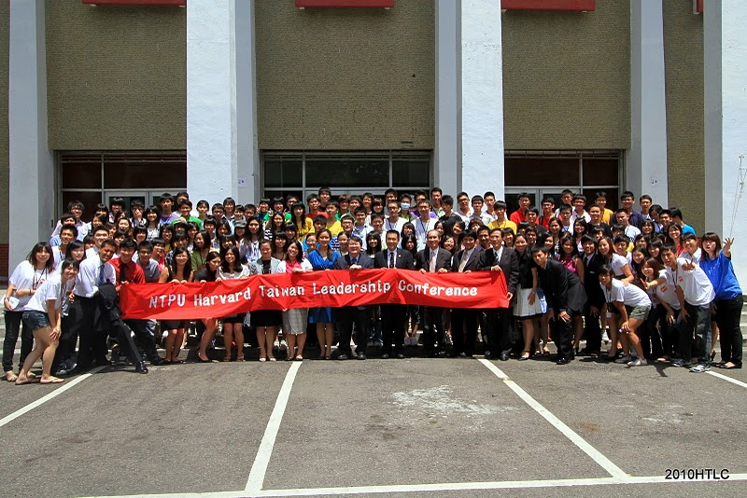
國立臺北大學校長與哈佛校友會林理事長參加開幕典禮

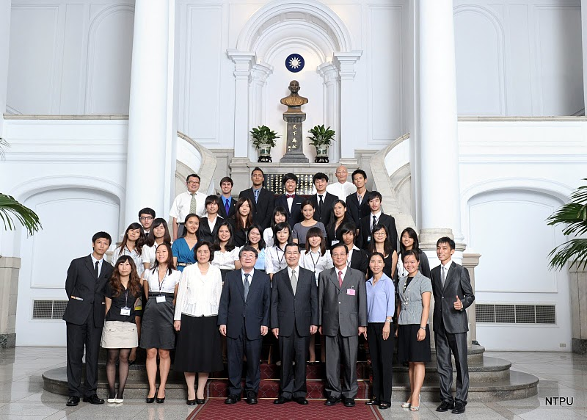
哈佛臺灣英文領導營2010拜會總統府與蕭副總統合照

